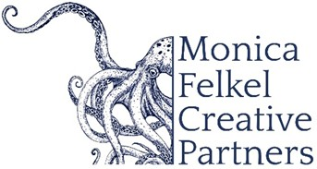

NORMAN HUYNH, conductor

American conductor Norman Huynh is known for his dynamic performances, inventive programming, and a natural ability to connect with audiences. He is Music Director of the Bozeman Symphony and the Britt Music & Art Festival Orchestra, and has appeared with leading ensembles including the St. Louis Symphony Orchestra, New York Philharmonic, San Diego Symphony, Oregon Symphony, Detroit Symphony Orchestra, and Spain’s Orchestra Sinfónica del Vallés.
Huynh’s versatility spans classical masterworks, premiers of contemporary works, and cross-genre collaborations with artists such as Itzhak Perlman and Augustin Hadelich; composers Kevin Puts, Andy Akiho, and Philip Glass; as well as artists in R&B, hip-hop, and popular music including Smokey Robinson, Gladys Knight, Wyclef Jean, and Nas. He is also acclaimed for conducting live orchestral performances of major film scores, including An American in Paris and the Harry Potter series.
A proud first-generation Asian American, Huynh began his musical journey as a trombonist in Alabama. He co-founded Baltimore’s Occasional Symphony, known for imaginative concerts in non-traditional spaces, and helped develop the Portland Symphony Orchestra’s award-winning PSO Explorers Program for young audiences.

Huynh resides in Bozeman, Montana, with his wife Catherine Young, and their son, Romeo.

10/2025

NOTE: Please discard previously dated materials and contact artist’s management before making any alterations or cuts. Please do not use previously dated materials.

